Automated Testing Assessment

You will need to simulate a Jenkins user’s everyday actions. Jenkins is a continuous integration tool which comes with an easy to use front end web application. We will be testing this web application.

**You will be expected to use best practice throughout. This includes using POM and CONSTANTS class**

**Have maven reports run the tests and create a report on all tests created**

**Upload to GitHub by the end of the day your code, and your report**

**Email trainers (below) your GitHub name and repository:**

[Chester.gardner@qa.com](mailto:Chester.gardner@qa.com)

[Christopher.perrins@qa.com](mailto:Christopher.perrins@qa.com)

Task One:

Automate the creation of a ‘new item’ using JUnit’s @TEST

* Login to Jenkins
* Click ‘new item’

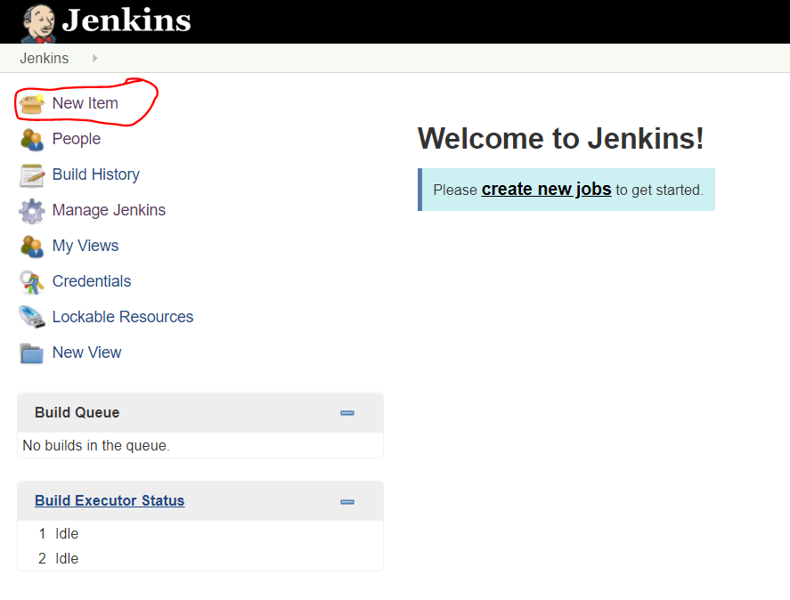

* Next enter some text for the name. Select Freestyle project. Then click ok

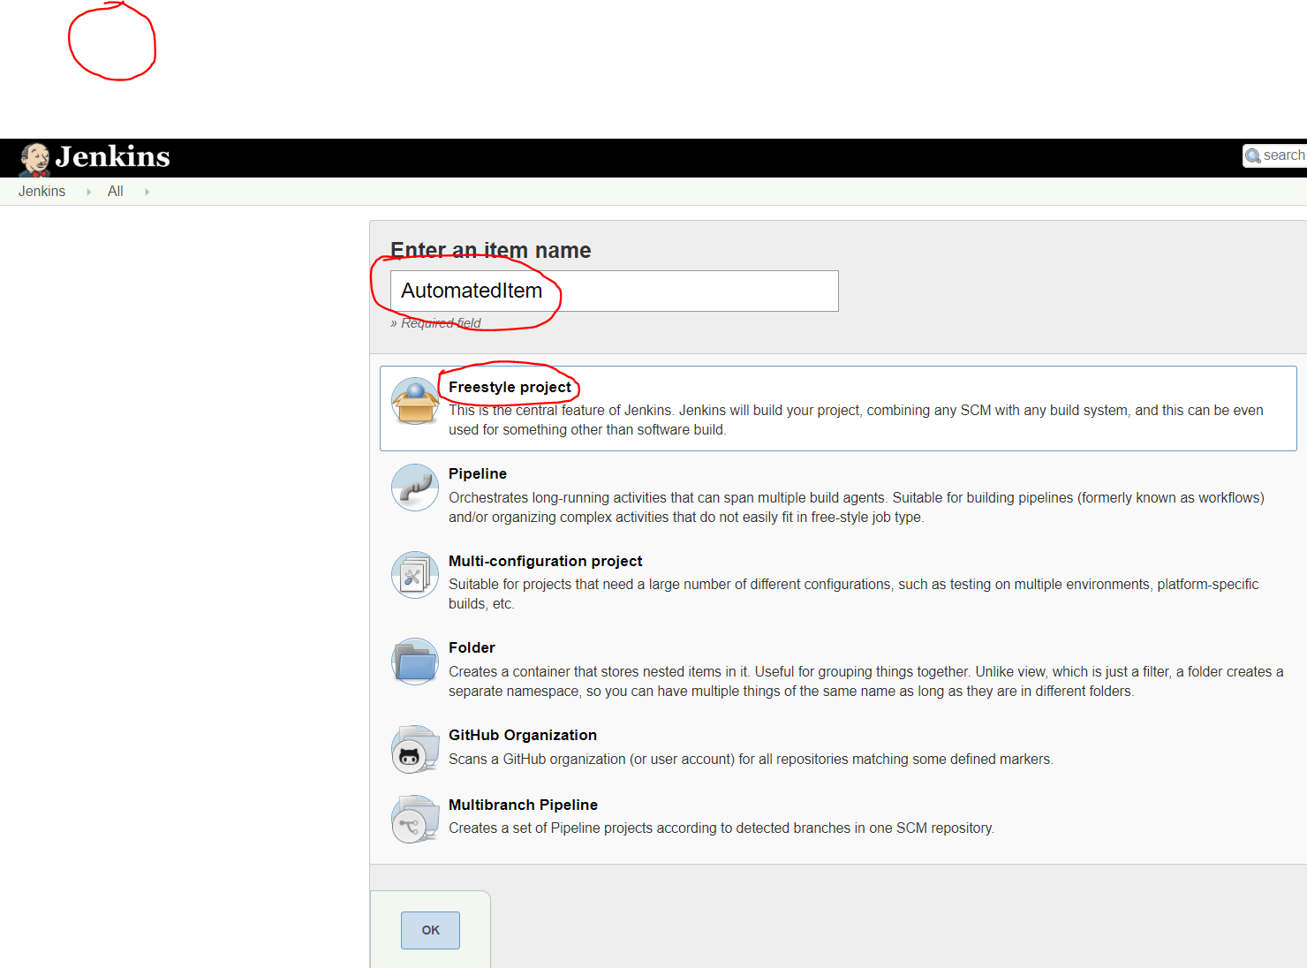

* Next press the save button

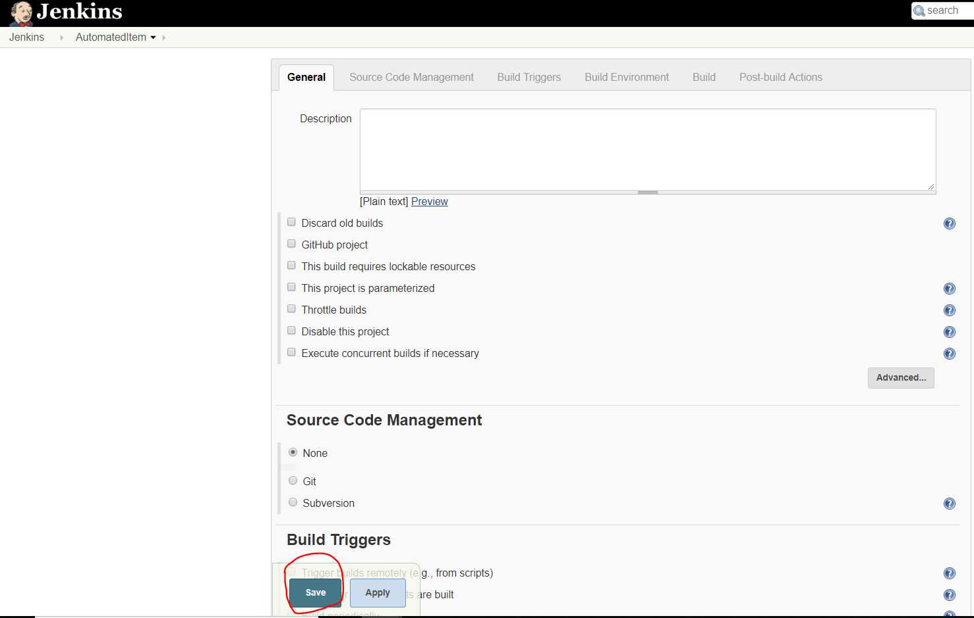

* Next click ‘Back to Dashboard’

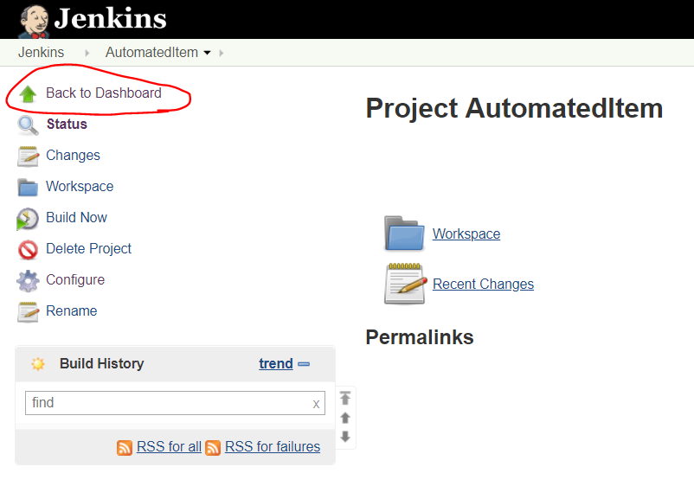

* Next assert that AutomatedItem has been added to your dashboard

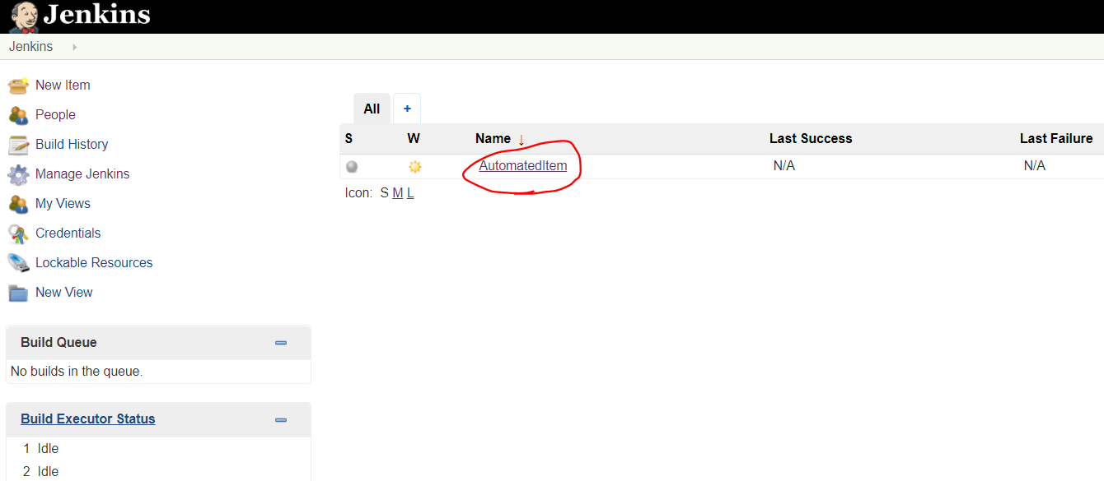

Task Two:

Add a user into Jenkins with EXCEL and @RunWith(Parameterization.class)

Automate the following steps:

* Click Manage Jenkins

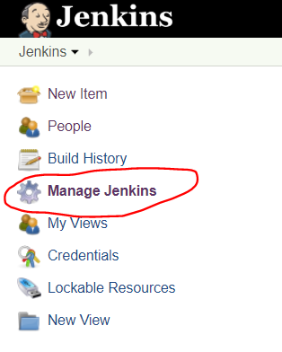

* Click Manage Users

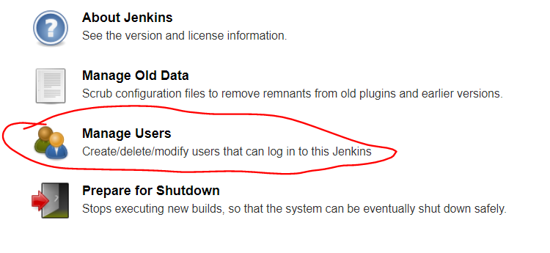

* Click Create User

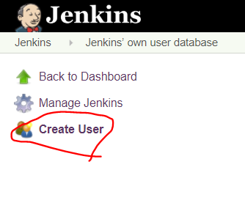

* Fill in the following form using the data from the excel sheet. Then click Create User.

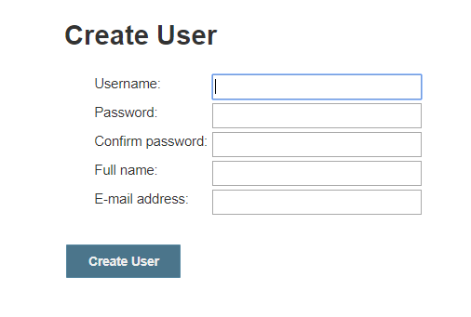

* After every input check that the username has been added on the people table:

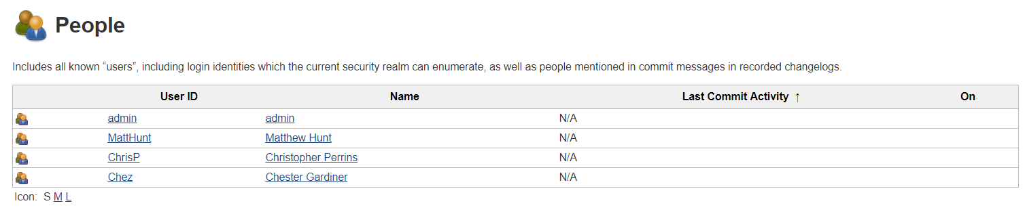

Task Three

Update the FullName of the selected users Using Cucumber Parameterisation

HINT: if you haven’t completed the previous exercise yet. Add them in manually

Import the feature file into Junit and parse it into a Cucumber readable state

Code for the tests in the .feature file sent

**YOU WILL NEED TO INSERT YOUR IP ADDRESS INTO THE FEATURE FILE where website is, as your ip address will not be http://00.000.000.000:8080**